Recovering Username and password
- If you don’t know or recall your SPU Username, click Need help in the bottom right corner:
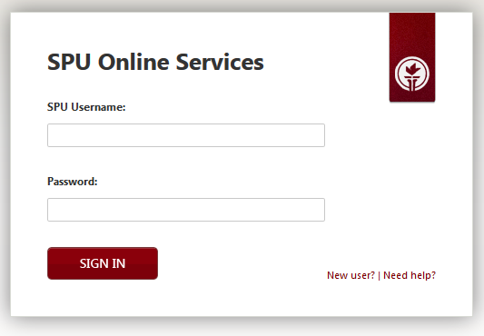

- Click on Recover Username
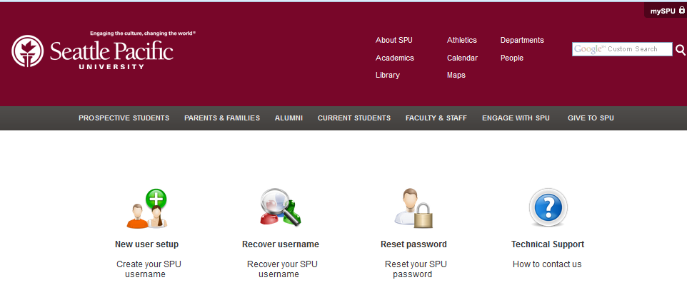

- Enter your email address and click Lookup SPU Username:
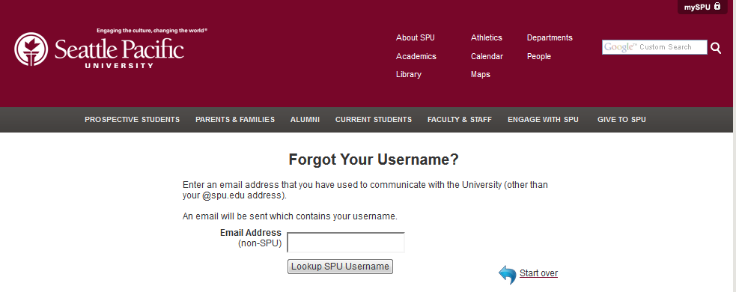

- You will be sent an email with the following information. Your SPU Username will be listed. In this example, the actual username was redacted for privacy
